Smart Car Accident Prevention
(S.C.A.P)



Team Members
Gaurav (CSE FINAL YEAR)
Raghav Khera (CSE FINAL YEAR)
Shubham (CSE FINAL YEAR)
Ankush kamboj (CSE FINAL YEAR)
Deepak Dhanda (CSE FINAL YEAR)

Table of Contents

Abstract 3
Introduction 4
Implementation 5
Block Diagram. 8
Circuit diagram 9
Result & Discussion 10
Advantages 11
Disadvantages 12
Future Scope 13
Appendix 15

Abstract
This project is about making cars more intelligent and interactive which will notify or resist user under unacceptable conditions, they may provide critical information of real time situations to rescue owner himself. Driver fatigue resulting from sleep deprivation or sleep disorders is an important factor in the increasing number of accidents on today's roads. In this paper, we describe a real-time online safety prototype that prevents the starting of the engine in the case of brake failure and warn the user through SMS and buzzer or LED. The purpose of such a model is to advance a system to detect fatigue symptoms in drivers and control the speed of vehicle to avoid accidents. The main components of the system consist of number of real time sensors like Ultra-Sonic Sensors .

Introduction
The Internet of Things (IoT) is the interconnection of uniquely identifiable embedded computing devices within the existing Internet infrastructure. Typically, IoT offers advanced connectivity of devices, systems, and services that goes beyond machine-to-machine communications (M2M)and covers a variety of protocols, domains, and applications.The interconnection of these embedded devices (including smart objects), is implemented in nearly all fields of automation enabling advanced applications like a SmartGrid. The term things in the IoT refers to a wide variety of devices such as heart monitoring implants, biochip transponders on farm animals, electric clams in coastal waters, automobiles with built-in sensors, or field operation devices that assist fire-fighters in search and rescue. Current market examples include thermostat systems and washer/dryers that utilize Wi-Fi for remote monitoring.

We are using Node MCU as the main control unit in this project project. When the system is switched on, LED will be ON indicating that power is supplied to the circuit. .This information will be sent to a mobile number through a text message. This message will be received using internet present in the circuit. The message will give the information of brake failure.

Implementation
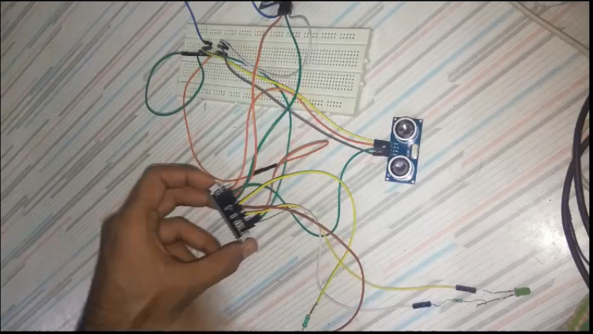
- ULTRASONIC SENSOR - The HC-SR04 ultrasonic sensor uses sonar to determine distance to an object. It offers excellent non-contact range detection with high accuracy and stable readings in an easy-to-use package. From 2cm to 400 cm or 1” to 13 feet.

NODE-MCU - Node MCU development board is an OPEN- SOURCE IOT development kit. It is the low cost hardware module which is used to connect IOT Application ex - Ultrasonic Sensor.
- BREADBOARD - A breadboard is a solder less device for temporary prototype with electronics and test circuit designs. Most electronic components in electronic circuits can be interconnected by inserting their leads or terminals into the holes and then making connections through wires where appropriate.

Connect the node MCU with ultrasonic sensor pins as Mentioned Below
Node MCU | Ultrasonic Sensor Front
D1 | Trigger
D2 | Echo
Vin | Vcc
GND | GND

Node MCU | Ultrasonic Sensor Back
D3 | Trigger
D4 | Echo
Vin | Vcc
GND | GND

Since there is only one pin we need to connect these sensor and node MCU through bread board. We Also require some method for distance calculations,for checking and updating of speed to the cloud platform to post the status of the break failure and the sms to the owner of the car And to connect to wi-fi and PUB-SUB communication.We require two Objects of Wifi Client And PUB-SUB client.
In the Setup Function we declare, serial.begin to display the function of circuit in the serial monitor.We declare as Sensor pin as declare trig pin front,trig Pin back,Eco Pin Front , Eco Pin Back as output pin and Input Pin Respectively. We also declare some other Variable alert Led And motor that we declare as output pin as setup function.
As the vehicle is turned on We need to check whether the brake is Working Properly or Not. So, we call check brake status function and store that function return value in the variable named Brake Fail status. We also need to require to declare its prototype at the top of the program since the brake can either be failed or not . so the return type of the function will be Boolean type and we are not not having any hardware brakes. So, we are using a brake variable that will tell whther the brake is fail or not . We will describe the functioning of the check brake status . If the value of the brake fail variable is true then, the function will send the speed to zero and return true to value.Otherwise it will return False.
After that we need To Connect to Wifi and MQTT protocol. So, we need 2 other methods wifi Connect And MQTT Connect that we Declare at the top of the Program as prototype. To connect to wifi need SSID and Password . So, we declare Global variable Name GSSID and password .SSID being the Name of the Wifi and password That you set As WPA or WPA2 to encyption Key .We will describe its function Later on .
Now, If the brake is failed we need to post that to the cloud and the cloud will send the sms to the owner of the car. And alert some leds or a buzzer that is connected to our sensor .So, we check whether the brake is failed or not.If the brake is failed then we post the data to the cloud .

BLOCK Diagram
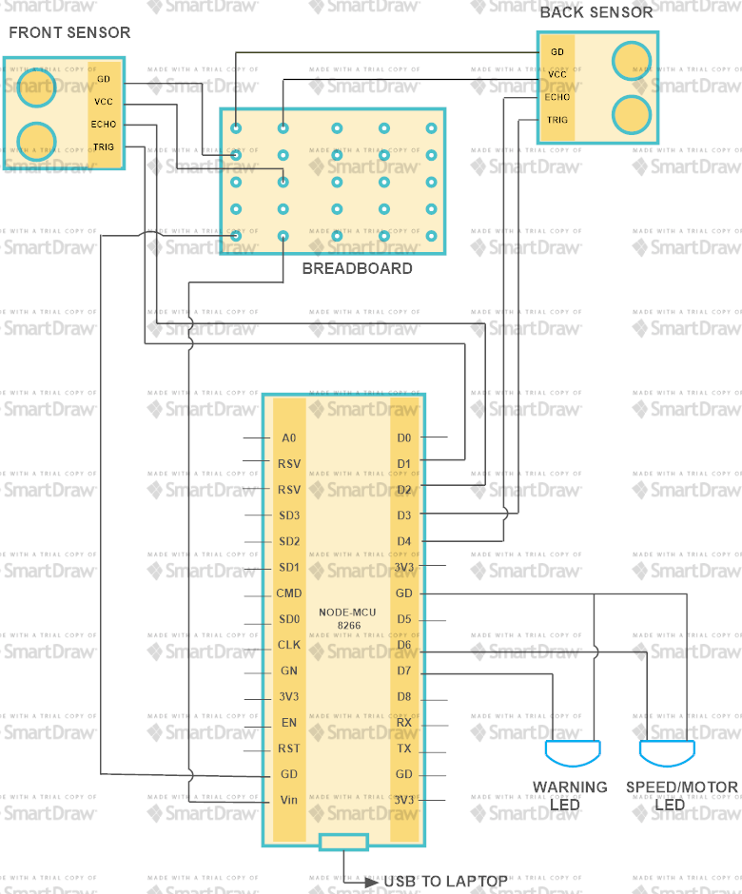

FLOW Diagram
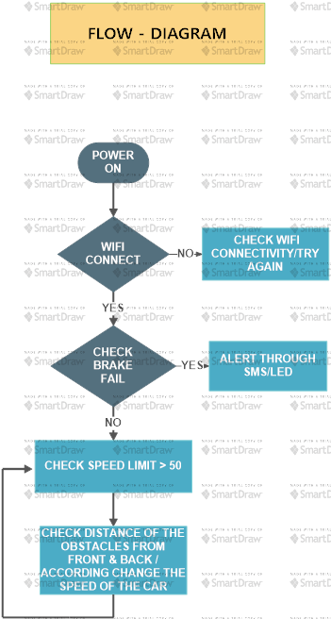

Result & Discussion
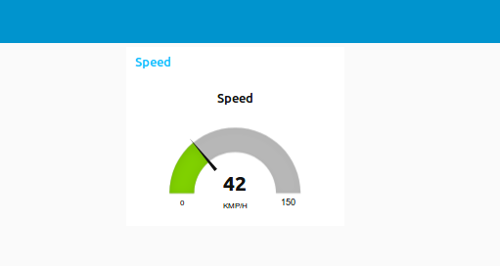
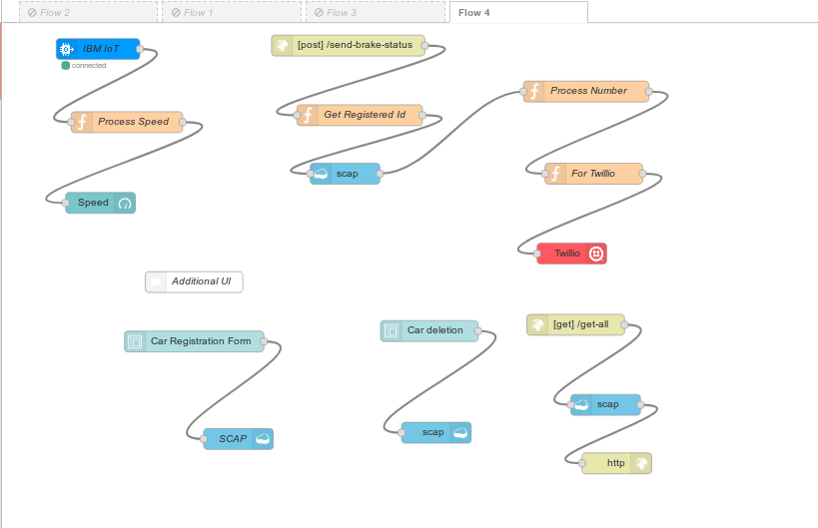
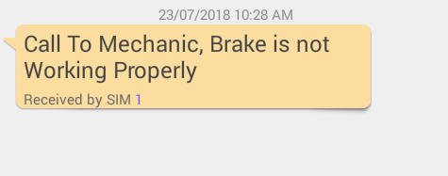
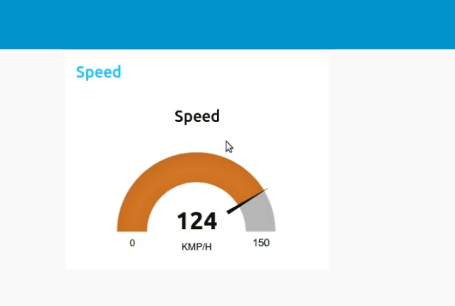
Advantages

- Our main motive to make this project is to reduce road accidents and save life not only the mankind but also the stray animals which accidentally come on the roads.
- This will help us in increasing road safety.
- This will also reduce the accidents in bad environmental conditions.
- Alerts will also helping gaining the drivers attention back on the road.
- Medical and other helps can reach the spot better.


Disadvantages
- Drivers may show negligence while driving by over reeling on the sensors.
- Sudden Brakes may lead to internal injuries.
- Failure of sensors may lead to accidents .



Future Scope


- Vehicle-to-Vehicle Communication: In future, the self-driving cars must communicate with each other for a smooth operation. Understanding the GPS coordinates and the speed to play a major role to facilitate this and will depend a lot on the new age sensor technology which will focus on the cars to communicate. The sensors also detect pedestrians, bicycles within its proximity and adjusts the car’s speed accordingly.
- Traction control system (TCS): The traction control system prevents wheel spin when starting off or accelerating, particularly on a slippery or wet road surface. While the antilock braking system (ABS) prevents the wheels from locking during braking by reducing the braking pressures, TCS ensures that the wheels do not spin when driving off or accelerating. To do this, the drive torque at each driven wheel is reduced correspondingly. TCS improves the traction of the vehicle and increases vehicle safety by avoiding unstable driving situations within the limits of physics.
- 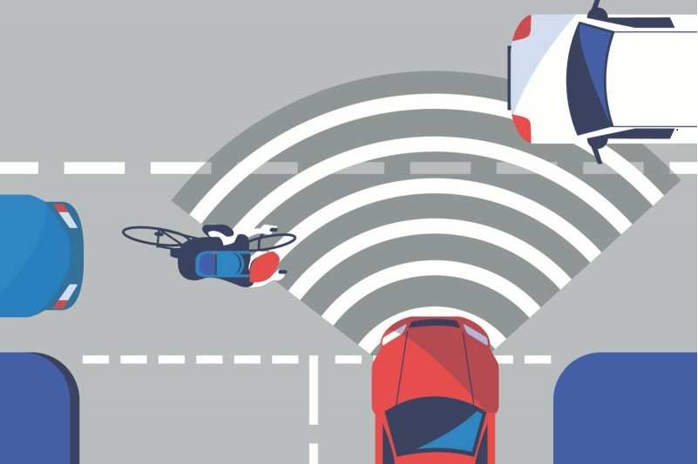

Appendix

#include <ESP8266WiFi.h>
#include <WiFiClient.h>
#include <ESP8266WebServer.h>
#include <ESP8266HTTPClient.h>
#include <PubSubClient.h>

//For PUBSUB - just used for demonstration of device
#define ORG "n69fbf"
#define DEVICE_TYPE "Beast-Device-type"
#define DEVICE_ID "Beast-Device"
#define TOKEN "lIOg8FAE@dL+dxJk(-"

char server[] = ORG ".messaging.internetofthings.ibmcloud.com";
char topic[] = "iot-2/evt/send-speed/fmt/json";
char authMethod[] = "use-token-auth";
char token[] = TOKEN;
char clientId[] = "d:" ORG ":" DEVICE_TYPE ":" DEVICE_ID;

const char* gssid = "Gionee M2";
const char* password = "15013029";
const char* host = "beast-app.eu-gb.mybluemix.net";
//

//Sensor Pin Number and Node MCU conncetion
const int trigPinFront = D1;
const int echoPinFront = D2;
const int trigPinBack= D3;
const int echoPinBack = D4;
int motor = D6;
int alert_led = D7;
char* _id = "fa2db5080fe437cb6affcbeab0d0640e";

//other variables defining states of car
boolean brake_failed=true, brake_failed_status;
int distFromFront,distFromBack;
int very_near = 5, near = 10, mid = 50, far =100;
int spd,speed_after_which_sensor_operates, max_range;

//Method Declaration
int get_distance(int, int);
boolean check_status_of_brake(boolean);
void post_brake_status();
void wifiConnect(const char *,const char *);
WiFiClient wifiClient;
PubSubClient client(server, 1883, wifiClient);

void setup() {
Serial.begin(115200);
delay(1000);
pinMode(trigPinFront, OUTPUT);
pinMode(echoPinFront, INPUT);
pinMode(trigPinBack, OUTPUT);
pinMode(echoPinBack, INPUT);
pinMode(motor, OUTPUT);
pinMode(alert_led, OUTPUT);

brake_failed_status= check_status_of_brake(brake_failed);
wifiConnect(gssid,password);
mqttConnect();
delay(10);
speed_after_which_sensor_operates = 50;
max_range = 150;
spd=0;
if (!brake_failed_status){
for(int i =0; i<100; i++)
{
spd +=1;
analogWrite(motor,spd*2);
delay(100);
}
}
else{
post_brake_status();
}
Serial.println(spd);

}

void loop() {
while (!brake_failed_status){

delay(100);
while(spd > speed_after_which_sensor_operates){
distFromFront = get_distance(trigPinFront, echoPinFront);
delay(100);
distFromBack = get_distance(trigPinBack, echoPinBack);
delay(100);
while (isnan(distFromFront) || isnan(distFromBack))
{
Serial.println("Your Sensor aren't working Properly, Connect Your Sensor Properly");
delay(1000);
}
if(distFromFront < very_near){
spd -= 12;
Serial.println("The Vehicle Ahead You is too closer, Stopping your vehicle and dropping Speed down to " + String(spd) );
}
else if (distFromFront<= near){
if (distFromBack <= near)
{
spd -= 10;
Serial.println("The Vehicle ahead You and behind You are approaching near, So decrasing speed down to " +String(spd));
}
else
{
spd -= 8;
Serial.println("The Vehicle ahaed You and behind You are approaching near, So decrasing speed down to "+ String(spd));
}
}
else if(distFromFront<=mid && distFromFront>near){

if (distFromBack<near){
spd += 10;
Serial.println("The Vehicle behind you is approaching towards You so increasing speed by "+ String(spd));
}
else{

spd+=7;
}

}
else if (distFromFront<=far && distFromFront>mid) {
if (distFromBack<near){
spd += 12;
Serial.println("The Vehicle behind you is approaching towards You so increasing speed by " + String(spd));
}
else{
spd+=10;
}
}
else{
//spd=60;

}
if (spd<0)
{
spd =0;
}
if (spd > max_range){

spd = max_range;
}
PublishData(spd,distFromFront,distFromBack, _id);
if (!client.loop()) {
mqttConnect();
delay(100);
}
analogWrite(motor,spd*4);
}
delay(100);
brake_failed_status = check_status_of_brake(brake_failed);
}
Serial.println("Brake Failed Call Mechanic");
delay(100);
while(brake_failed_status){
digitalWrite(alert_led,HIGH);
delay(100);
digitalWrite(alert_led,LOW);
delay(100);
}

}

int get_distance(int t_pin, int e_pin){
int distance;
int duration;
digitalWrite(t_pin, LOW);
delay(2);
digitalWrite(t_pin, HIGH);
delay(10);
digitalWrite(t_pin, LOW);
duration = pulseIn(e_pin, HIGH);
distance= duration*0.034/2;
return distance;

}

boolean check_status_of_brake(boolean brake){

if(brake_failed){
spd=0;
return true;
}
else{
return false;
}
}

void wifiConnect(const char *ssid,const char *passw) {

Serial.print("Connecting to ");
Serial.println(ssid);

WiFi.mode(WIFI_STA);
WiFi.begin(ssid, passw);

while (WiFi.status() != WL_CONNECTED) {
delay(100);
Serial.print(".");
if (brake_failed_status){
digitalWrite(alert_led,HIGH);
delay(100);
digitalWrite(alert_led,LOW);
delay(100);
}
}

Serial.println("");
Serial.println("WiFi connected");
Serial.println("IP address: ");
Serial.println(WiFi.localIP());
}

void post_brake_status()
{
Serial.print("Connecting to ");
Serial.println(host);

String postData = "_id="+String(_id);
HTTPClient http;
http.begin("http://beast-app.eu-gb.mybluemix.net/send-brake-status");
http.addHeader("Content-Type", "application/x-www-form-urlencoded"); //Specify content-type header
int httpCode = http.POST(postData); //Send the request
String payload = http.getString(); //Get the response payload

Serial.println(httpCode); //Print HTTP return code
Serial.println(payload); //Print request response payload

http.end();

}
void mqttConnect() {
if (!client.connected()) {
Serial.print("Reconnecting MQTT client to ");
Serial.println(server);
while (!client.connect(clientId, authMethod, token)) {
Serial.print(".");
delay(500);
}
initManagedDevice();
Serial.println();
}
}
void initManagedDevice() {
if (client.subscribe(topic)) {
Serial.println("subscribe to cmd OK");
} else {
Serial.println("subscribe to cmd FAILED");
}
}
void PublishData(int spd,int frontDist,int backDist,char *id){
if (!!!client.connected()) {
Serial.print("Reconnecting client to ");
Serial.println(server);
while (!!!client.connect(clientId, authMethod, token)) {
Serial.print(".");
delay(500);
}
Serial.println();
}
String payload = "{\"d\":{\"speed\":";
payload += spd;
payload += ",\"frontDist\":";
payload += frontDist;
payload += ",\"backDist\":";
payload += backDist;
payload += ",\"_id\":\"";
payload += id;

payload += "\"}}";
Serial.print("Sending payload: ");
Serial.println(payload);
if (client.publish(topic, (char*) payload.c_str())) {
Serial.println("Speed :"+ String(spd));
}
else {
Serial.println("Publish failed");
}
}

